TASK 13-Network tab logs

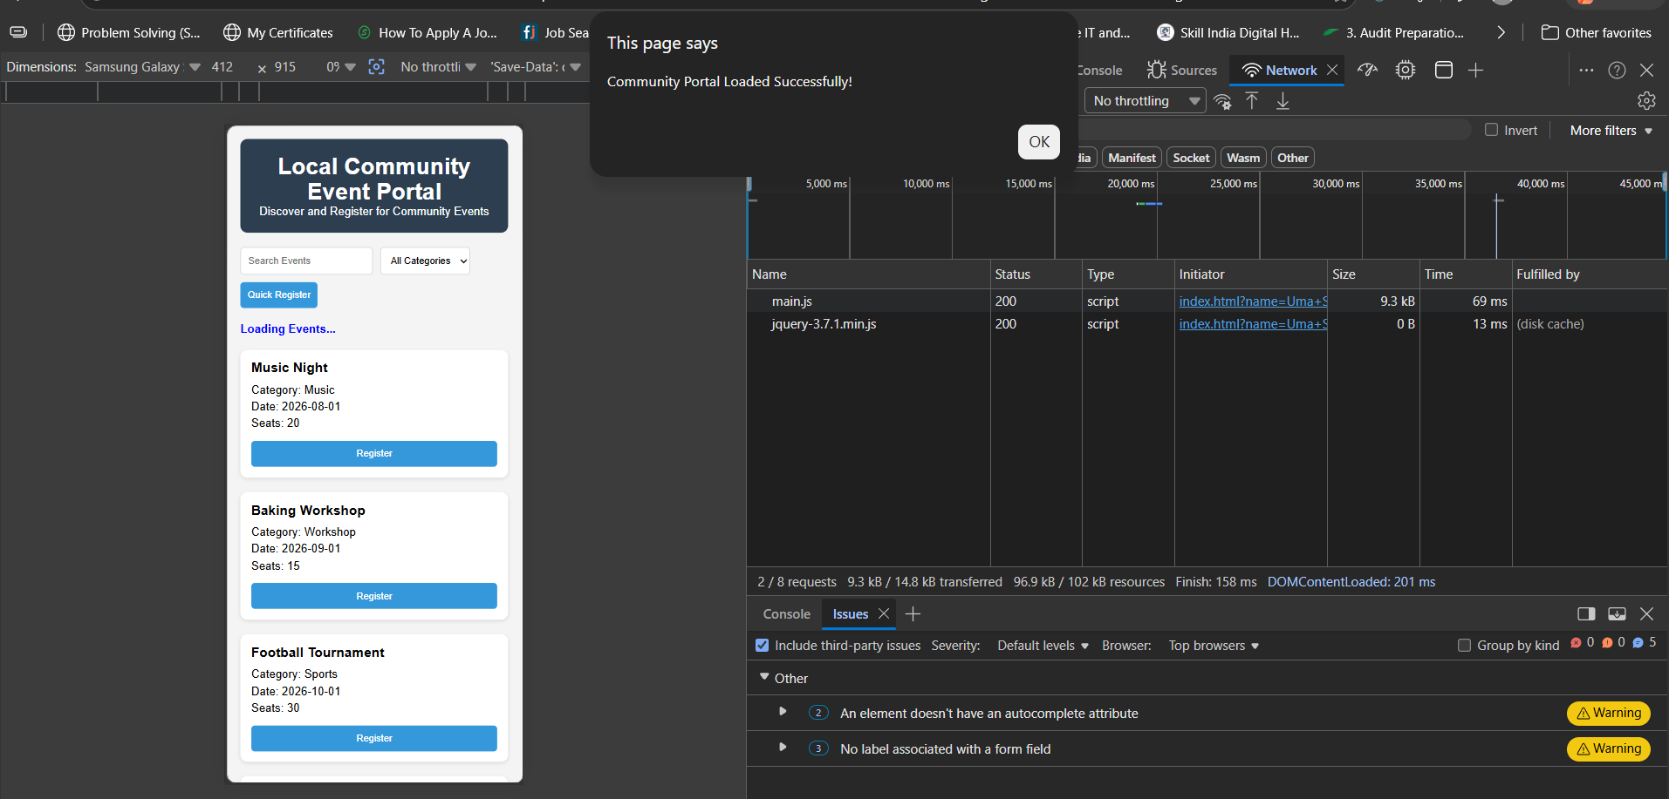

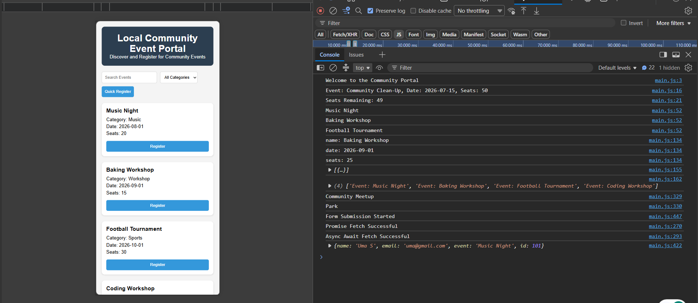

Task 14: One benefit of moving to frameworks like React or Vue

React and Vue provide a component-based architecture, making code more reusable, maintainable, and scalable for large applications.

